**Instrument Choice List**

[An illustration of a Western concert flute](http://en.wikipedia.org/wiki/Image:Flute_1911.jpg)flute

[Clarinet](http://en.wikipedia.org/wiki/Image:Clarinet.jpg) Clarinet [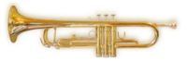](http://en.wikipedia.org/wiki/Image:Trumpet_1.jpg)Trumpet

[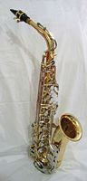](http://en.wikipedia.org/wiki/Image:Saxophone_alto.jpg) Saxophone [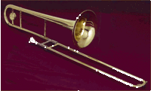](http://en.wikipedia.org/wiki/Image:Posaune.gif) Trombone

[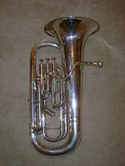](http://en.wikipedia.org/wiki/Image:Euphonium1.JPG) Baritone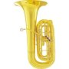 tuba [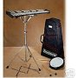](http://www.google.com/product_url?q=http://www.amazon.com/Ludwig-M651-Bell-Kit-Drum/dp/B000N9GZPM&fr=AGts0aXIo9VAHA2h3_8F9u_VQH8OZQQBefvpz6ymA5zRxeGSIzC7uNJD0QQWPw41MyLz6ZPfr9BoQcMUkTbtv3f1tMXOBA6BZGZgik-AOxyCXmt-2Hx1jTF51TbE_RCM6-VGK7c1Uv0AAAAAAAAAAAA&gl=us&hl=en&ei=tYQPTMugN4ODlwfd3vn4AQ&sa=image&ved=0CBwQ9gIwBDgA)Percussion Kit

[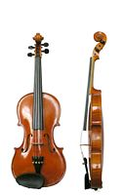](http://en.wikipedia.org/wiki/Image:Violin_VL100.jpg)[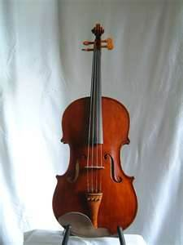](http://www.bing.com/images/search?q=viola+picture&view=detail&id=7DF023BC328332D2B452D3D1D46A3C9692E5250A&first=0)[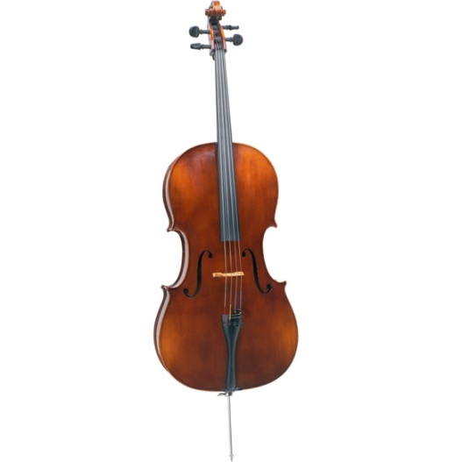](http://www.encoremusiclessons.com/images/about_page_imgs/cello-lg.jpg)

Violin viola cello