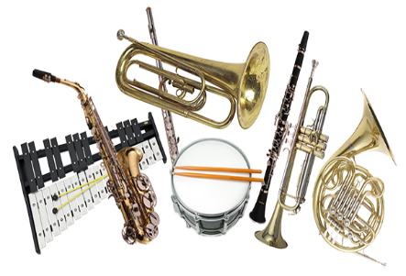
McConnellsburg Elementary
This Photo by Unknown Author is licensed under CC BY-NC
Band Instrument Lesson Information 2022-2023
Student Name:
Classroom Teacher:
Parent/Guardian Name:
Student Email Address:
Parent/Guardian Email Address
Parent/Guardian Phone:
Instrument Choice:
Second Instrument Choice:
Circle one of the following:
- Rent from Menchey
- Rent from another company
- Own Instrument
Please return this form by email to lstepler@cfsd.info or return a paper copy to Mrs. Conner by September 16th!

